**AutoCAD Essentials**

Question 1:

**How can you draw a line at some angle?**

Ans:

Type L then enter, define the first point, give length (Ex: 150mm) then press the tab to go to the angle section and enter the angle you want (Ex: 30 for 30 degree).

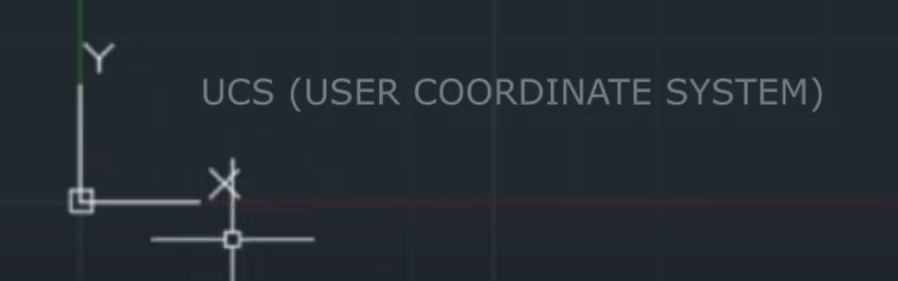

These above things is called UCS as User Coordinate System)

Question 2:

**How to change the size of the cursor and the size of the pick box (The box on the middle) and (the cursor is called a crosshair)?**

Ans:

Right-click on the mouse button, go to options, go to display, and change the crosshair size as you want. Then go to selection and change the pick box size.

Question 3:

**How to change the drawing unit (in mm or inch)?**

Ans:

type UN for newer versions of CAD or units for older versions. Change the insertion scale to mm, and make the precision to 0.0000 or 0.000 in the length section for precise drawing.

Question 4:

**How to change the Drawing limits?**

Ans:

Type limits for older versions or lim for newer versions, and then it will ask for the lower end corner, simply press enter then it will ask you upper right corner distance, and set the dimensions of X and Y according to your drawing. Remember that the limit should be greater than the entire drawing. After limiting, press Z enters A enter for Zooming all.

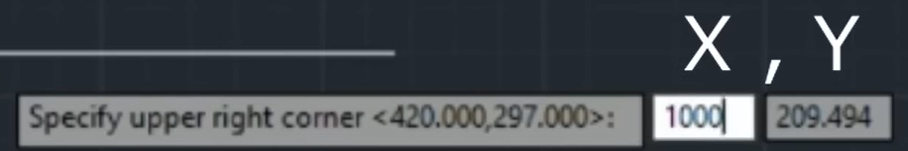

Make 4 toggle keys keep on for better drawings. 1. Dynamic Input, 2. Orthomode, 3. Object Snap Tracking, 4. Object Snap (Right Click on the osnap option and tick all the points for better tracking).

Question 5:

**Where we use the polyline?**

Ans:

When we need line and arc at the same drawing, then we will use pline or polyline.

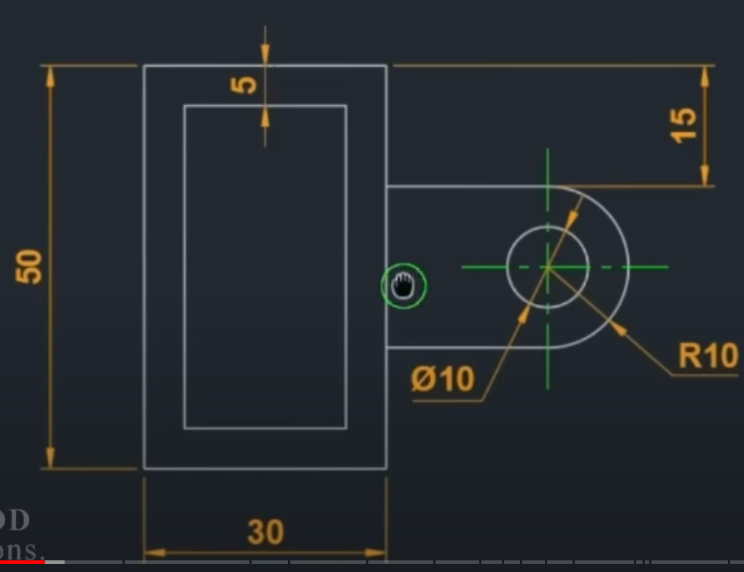

The above picture shows that the line can be used for making the curve 15 mm from the upper corner. So we need to draw the line from the 15 mm below. So first we need to select the pline, then without clicking on the upper corner, we can come down (drawing se Bhi neeche) using the tracking and then enter 15 to start the line from 15 mm below the corner. Then move the cursor to the left and type 20 then right-click on the mouse and click on arc then down the cursor and type 20 for diameter and then right-click again to make the line and then complete the drawing.

Question 6:

**How to make a centre line? With the different colours?**

Ans:

Make line as usual. Then convert them to a center pattern. For that change the line type by layer to center by going others then load. Change the global scale factor to your needs by going to show details on the line type manager. After doing this click the lines and change the colour.

Question 7:

**How to make an Arc?**

Ans:

There are several processes for making an Arc. Maximum we use 1. 3-point arc, 2. Start-Center-end, 3. Start-end-radius. Maximum we use start-end-radius.

Question 8:

**How to make a rectangle?**

Ans:

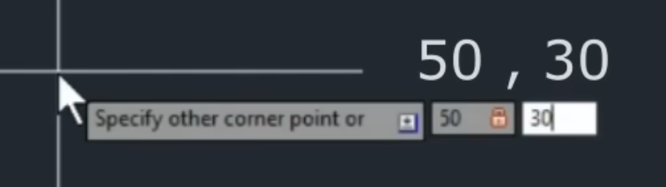

If you want to change the value of the centre line without impacting the values of other centre lines then select those lines and right-click the mouse go to properties then change it.

Question 9:

**How to make a polygon?**

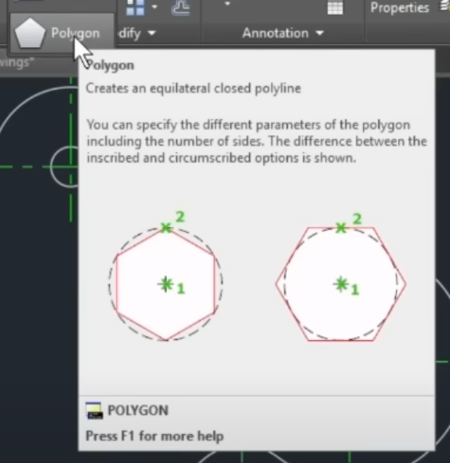

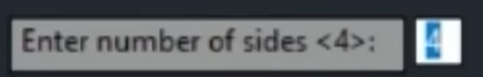

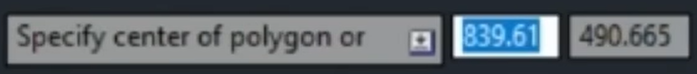

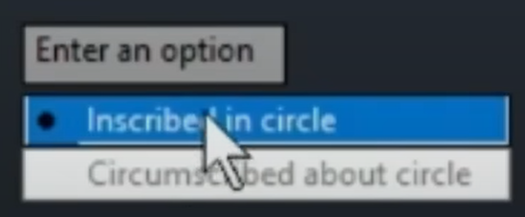

Inscribed means the polygon is under a circle and circumscribed means the circle is under a polygon.

This helps in providing the radius of the polygon in the last.

You can use a polygon for making triangles also.

When you see a smooth curve without any corners that means there are circles used using tangent. Otherwise, if you see a corner or rough edge then that means there are normal circles used.

Whenever you see a circle, you need to draw a centre line.

Question 10:

**How to separate all lines from rectangles?**

Ans:

Using Explode

**Fillet**

Before Fillet

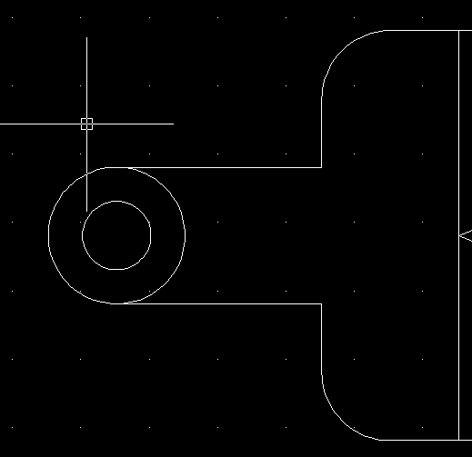

After Fillet

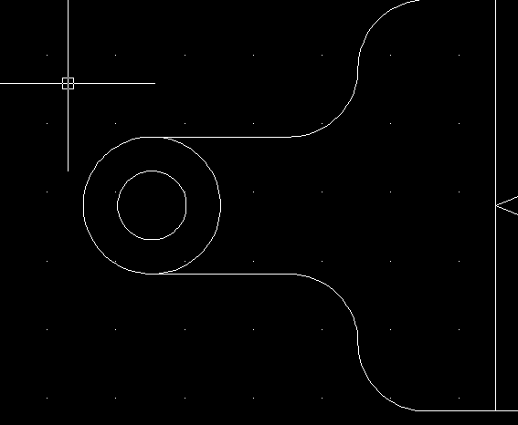

**Chamfer**

Before Chamfer

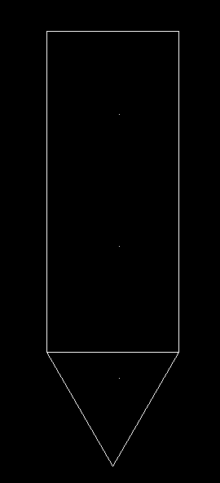

After Chamfer

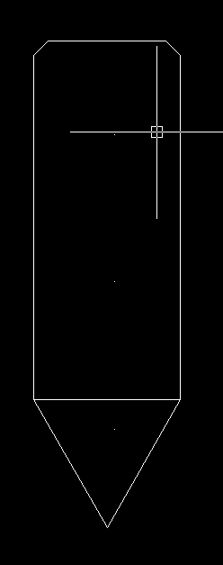

For using Chamfer, type chamfer then right click and choose distance (You can choose different as per requirements), then give distance (here 1 enter then 1 enter) then select the object from where you want to start chamfer, then select another line where you end the chamfer.

**How to use projection line**

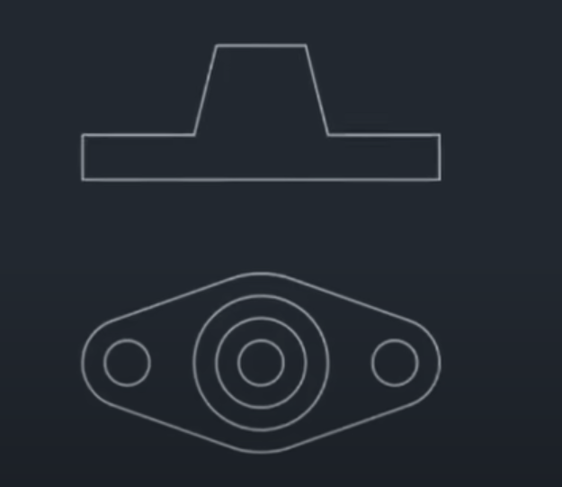

This kind of drawing can be done by using a projection line. The projection line can be taken as a ray. Simply type ray to get the projection lines.